ECP Patching instruction is available in this official documentation:

<https://docs.containerplatform.hpe.com/52/reference/global-settings/System_Maintenance.html>

## Order of nodes to Patch:

|  |  |
| --- | --- |
| # | Node (all nodes in rolling model i.e., 1-by-1) |
| 1 | Controllers:   1. Shadow 2. Arbiter 3. Primary |
| 2 | Gateway hosts |
| 3 | Mangers |
| 4 | Istio Gateway workers |
| 5 | Kubernetes worker |

### Services to check in all the nodes:

#### Before patching starts:

Make sure /var/lib/docker mount point is present. Take screenshots of “df -h” and “lsblk”

Check the firewalld status

Sudo systemctl status firewalld

#### After patching is completed:

1. Make sure server is rebooted after patching with “**uptime**”
2. Make sure /var/lib/docker mount point is present. Compare screenshots of “**df -h**” and “**lsblk**”
3. Make sure firewalld service is running using **systemctl status firewalld** and check the below command to makesure all iptable rules are being created from ECP-Product end.

“sudo iptables -S | grep bd_”

If iptable rules are not found, please restart bds-controller and check the iptables after couple of minutes.

sudo systemctl restart bds-controller

sudo iptables –S | grep bd_

1. Che ck Docker version with “**docker -v**” it should be “Docker version 19.03.7, build 7141c199a2” Please also makesure the patching process should not create any docker level issues such as docker upgrade/downgrade.
2. Check OS version with “**cat /etc/*lease**” it should be Version 7.9
3. Check Kernel Version with “**uname -r**” it should be 3.10.0-1160.21.1.el7.x86_64
4. **Check timedatectl and if time is not in sync please perform the below steps:**

**sudo systemctl restart chronyd**

**chronyc -a makestep and wait till the time is in sync.**

1. **chronyc tracking** check for Leap status : Normal

### Below are the services that has to be checked post patching of servers from each server group (systemctl status <service-name>):

|  |  |
| --- | --- |
| Group Name | CaaS ECP-Services to be checked after Patching |
| ECP-CONTROLLERS | docker.service  bds-controller.service  chronyd.service  bds-monitoring.service  bds-cgroup.service  httpd.service(Primary and Shadow)  **Primary, shadow and arbiter status should be UP:** From any controller node run bdconfig --hainfo |
| ECP- GATEWAYS | docker.service  bds-controller.service  chronyd.service |
| ECP -K8HOSTS(Including Istio-Gateway hosts) | docker.service  bds-controller.service  chronyd.service  kubelet.service  bds-monitoring.service  bds-cgroup.service |
|  |  |

### Please ensure the following while patching:

1. Any RPM packages related to bluedata should not be removed. Hence ask Linux team to take backup of /etc/yum.repos.d/ before patching and restore if the bluedata repos are missing post patching.

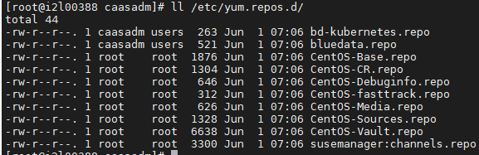

1. **Docker version should not be updated at any cost**. This has been directly provided by product team and become very complicated if updated.

### Troubleshooting tips:

1. Please check logs in this folder if controller services are failing - /var/log/bluedata
2. Please check individual containers logs – for mountpoint / posix / monitoring service issues.